Journal-2

1.Delete directory "ASP" with all its sub-directory with single command.

Code:

rm –r Asp

Output:



2.Move to the "Web" directory under "ASP" and create following files.

1. Create a "Stud" file which contain 5 student information(id,name,city,dob,mob) seperated field with ",".
2. Also Create "Intro" file and write more than 5 line about you.

Code:

cd asp

cd web

1.cat >Stud.txt

2.cat>Intro.txt

Output-1:

Output-2:

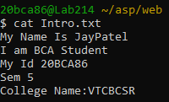

3.Create another file "Kernel" which contain list of feature of kernel and copy it into "OS" file using cat command.

Code:

cp Kernel.txt OS.txt

Output:

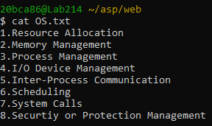

4.Append data into "Intro" file with more than 10 line about you . Add multiple blank line in file.

Code:

Cat >> Intro

This is Unix Shell

My Village Name Is:Zervavra

TYBCA

Output:

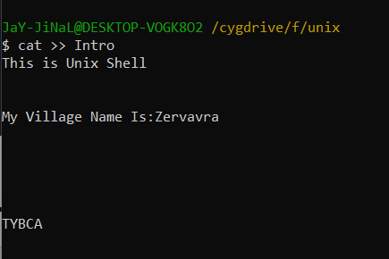

5.Make a copy of "Stud" file and call it "Stud.bk" and save it under the same directory.

Code:

Cat stud>stud.bk

Output:

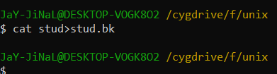

6.Display both file with visual character and line number.

Code:

Cat -n stud | cat -n stud.bk

Output:

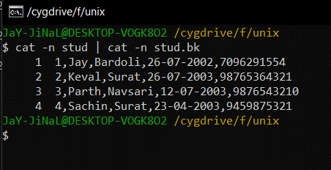

7.Count the total number of lines in “Stud” file with words and character.

Code:

Wc stud

Output:

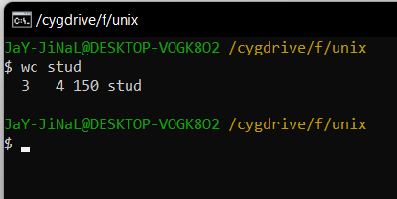

8.List out all directory created in your drive.

Code:

Ls -d \*/

Output:

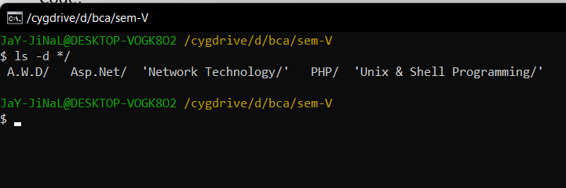

9.Recursively list all directory in your drive.

Code:

Ls -r

Output:

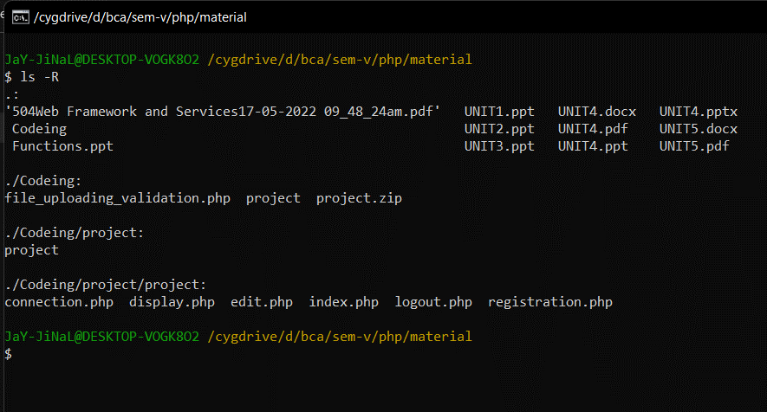

10. Display long listing details of all files and folders in “Web” directory along with hidden files.

Code:

Ls -all

Output:

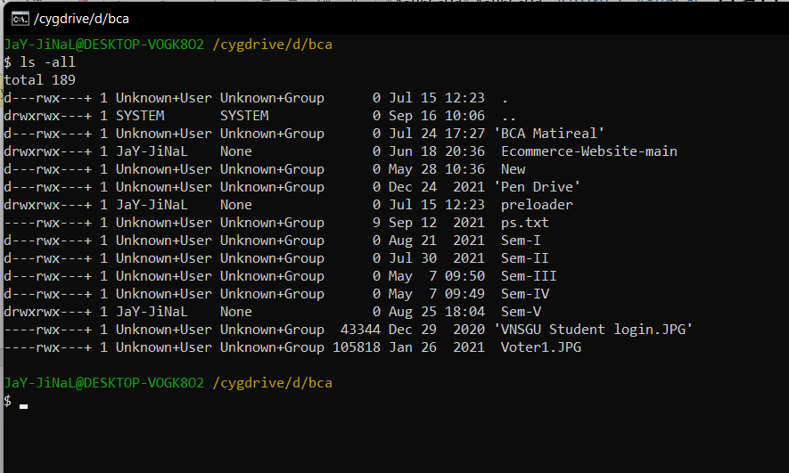

11.List out all files including hidden files in current directory in reverse order.

Code:

Ls -ar

Output:



12.List all files and directory in sorting order as per as its size.

Code:

Ls -S

Output:

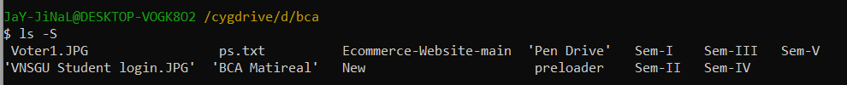

13. List all file details as per as its modification time.

Code:

Ls -lt

Output:

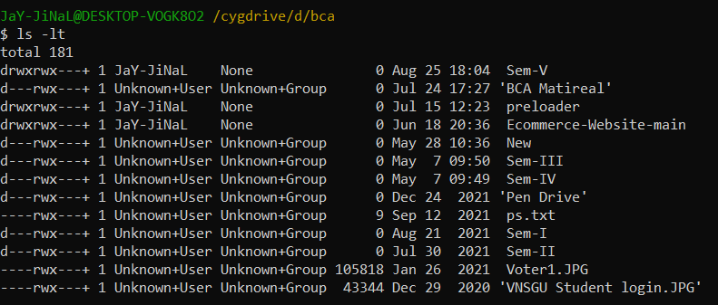

14. Copy and rename “Stud” and “Intro” file into “Temp” folder of “Exam” in single command.

Code:

Cp stud into Exam/Temp

Output:

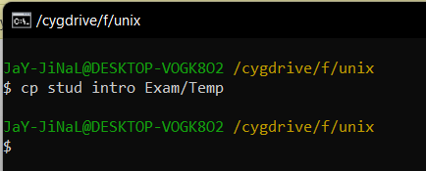

15. Copy “Intro” file in “Web” folder under “ASP” to the parent directory using dot notation.

Code:

Cp intro ../..

Output:

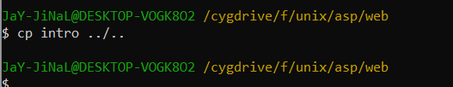

16.Recursively copy entire “Web” folder into “PHP”.

Code:

Cp -r Exam ../Unix1

Output:

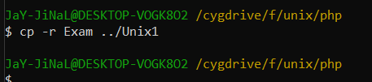

17. Recursively copy entire “Web” folder into “PHP”.

Code:

Cp -r web php

Output:

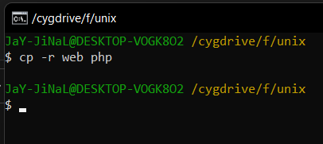

18.Rename “Stud” file with “Student”.

Code:

Mv stud student

Output:

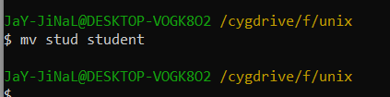

19.Remove “Student.bk” file.

Code:

Rm stud.bk

Output:

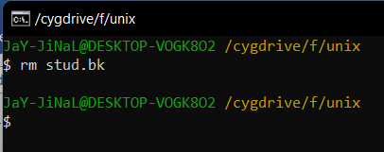

20.Remove “Temp” folder with all its subdirectories and files.

Code:

Rm -r temp

Output:

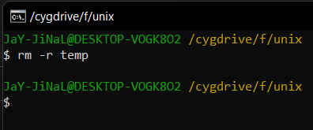

21.Create empty files temp1, temp2 and temp\* in UNIX directory. Delete only the “temp\*” file.

Code:

Rm ‘temp\*’

Output:

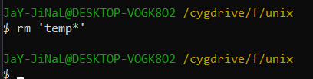

22.Forcefully delete all files from PHP directory.

Code:

Rm -rf php

Output:

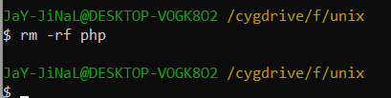

23. Move “Student” file into “UNIX”.

Code:

Mv student Unix1/

Output:

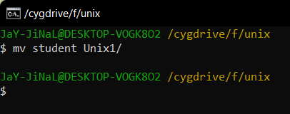

24.To find file having a .txt extension.

Code:

Find \*.txt

Output:

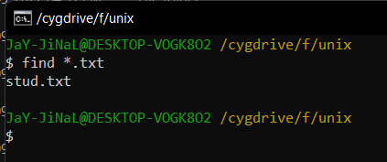

25.To find file having size greater than 5.

Code:

Find ~ -size +5b

Output:

